Mobile Add Community rewards

1. Click on My account
2. Under loyalty- click on community rewards

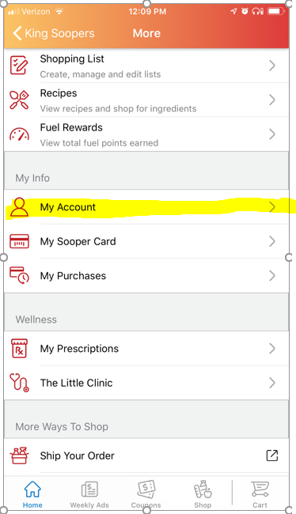 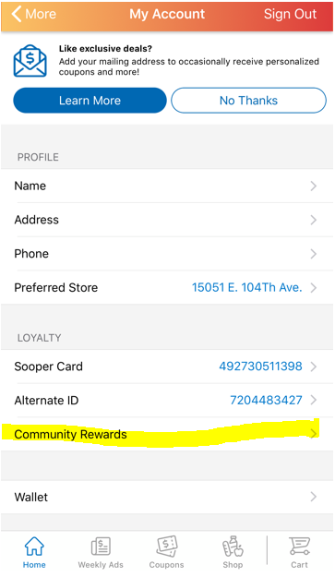

1. You can search under the organization name or just type in the Number SH252.

